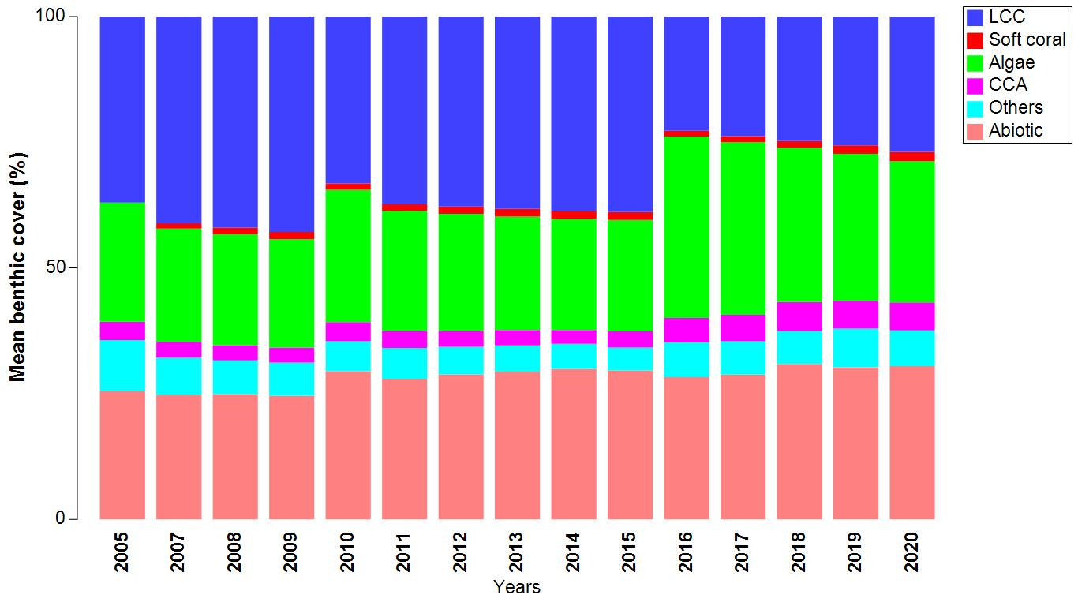

Temporal changes of benthic cover in Gulf of Mannar

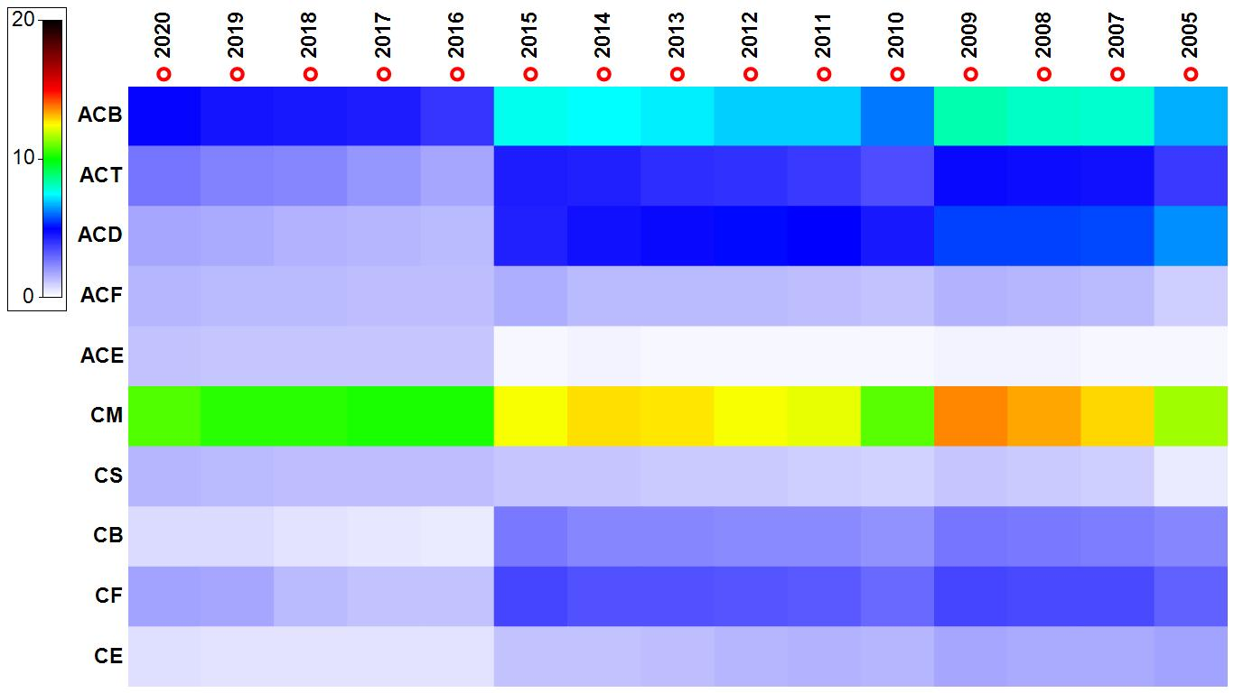

Temporal changes of coral types in Gulf of Mannar

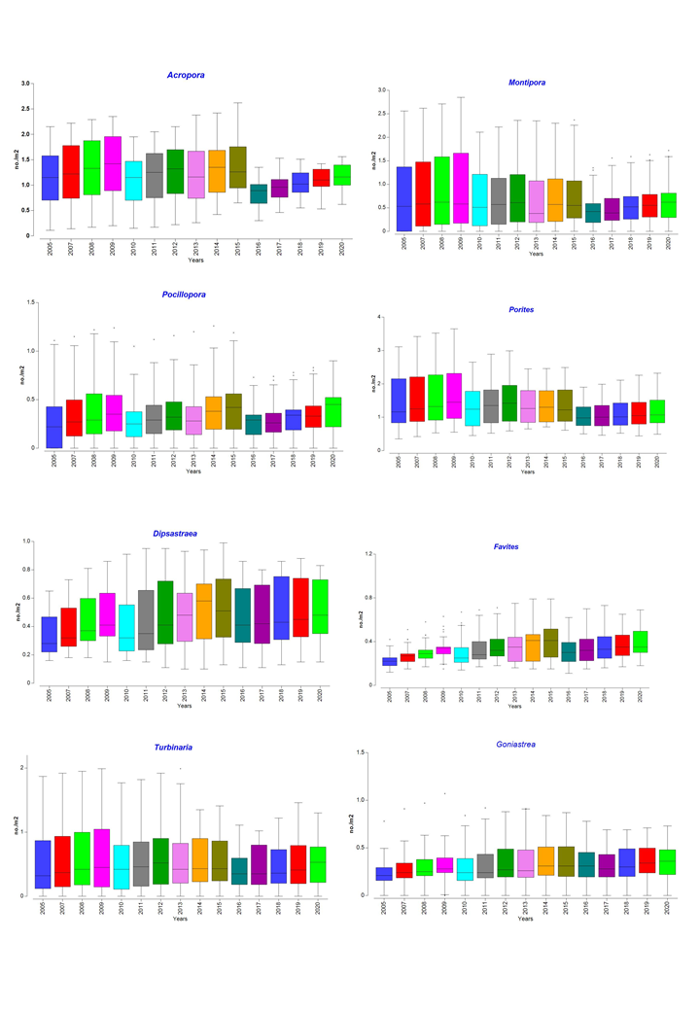

Box plot showing temporal changes of juvenile coral density in Gulf of Mannar

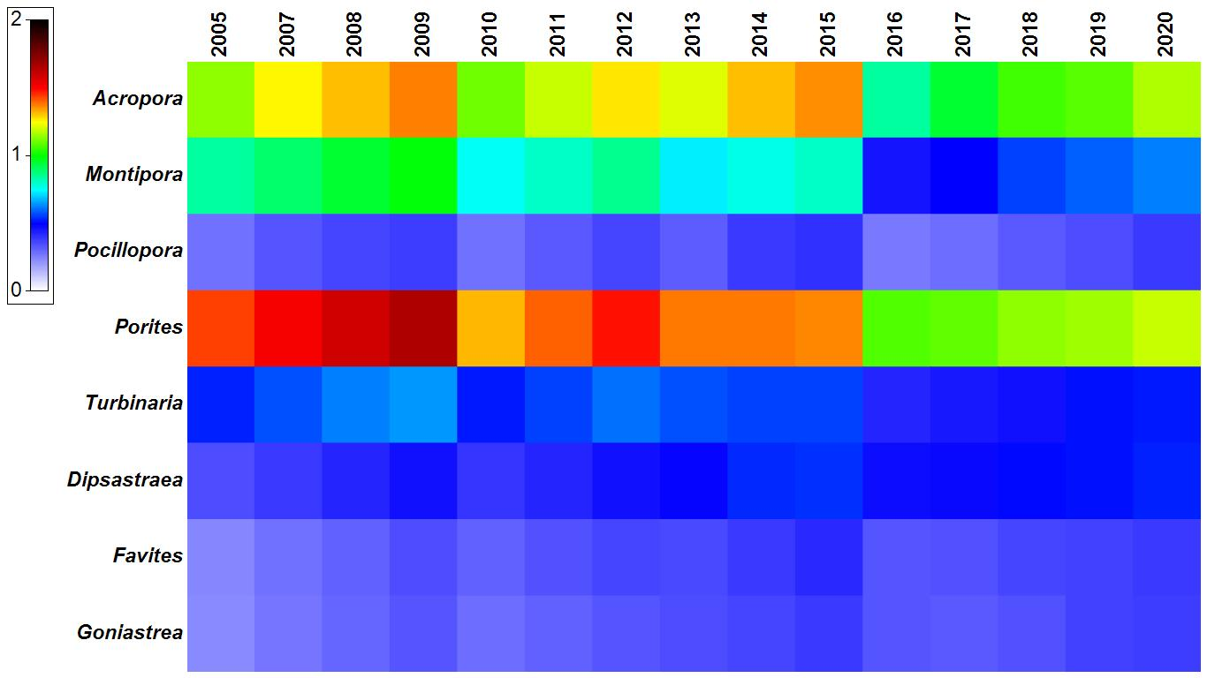

Temporal changes of juvenile coral density composition in Gulf of Mannar
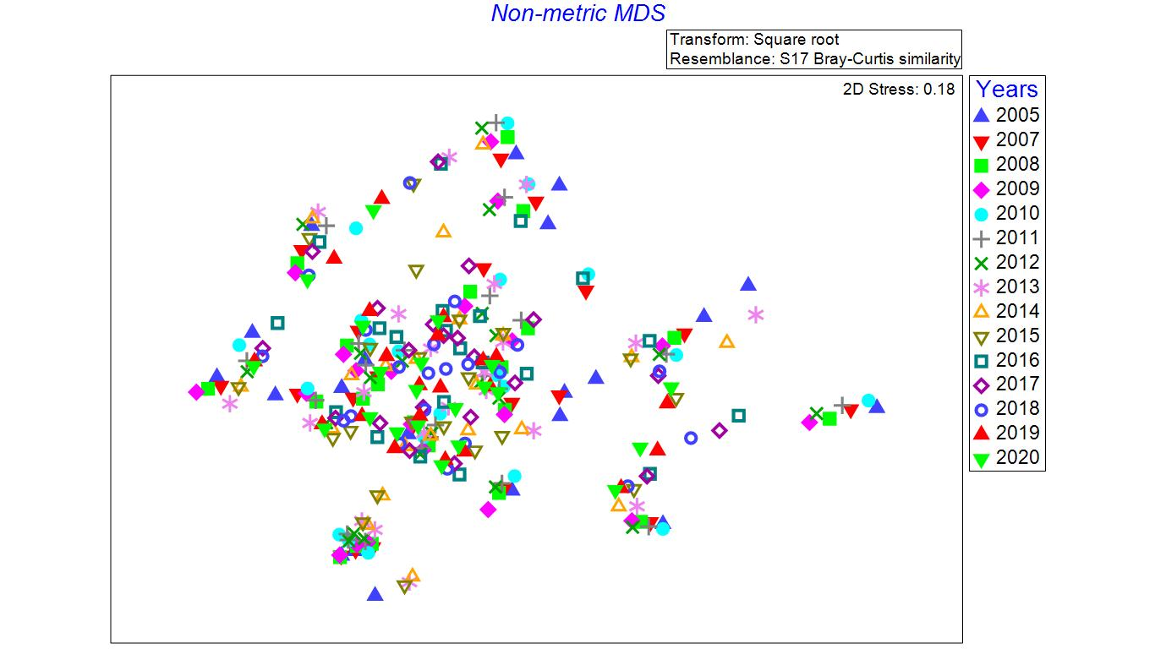

nmMDS ordination indicates temporal assemblage pattern of juvenile coral abundance in GoM

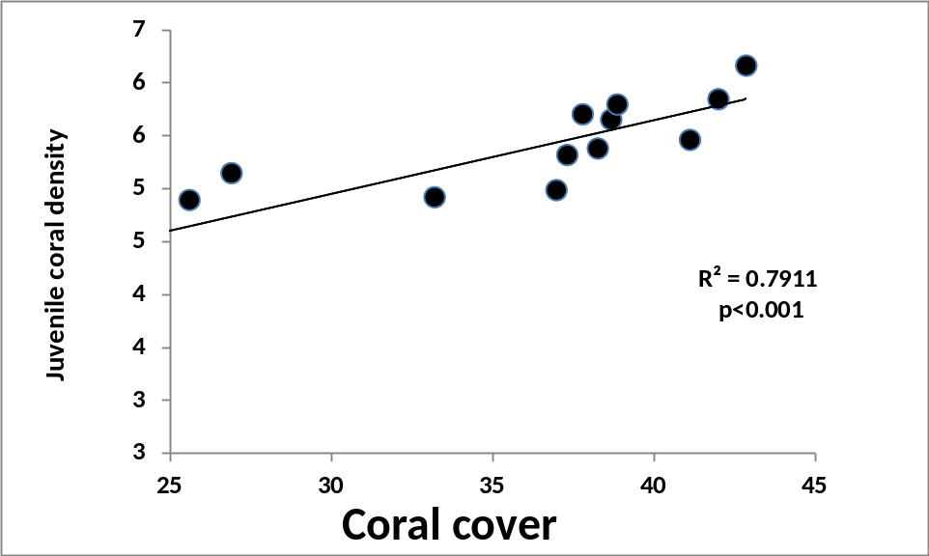

Relationship between of juvenile coral abundance and coral cover between 2005 and 2020 in GoM
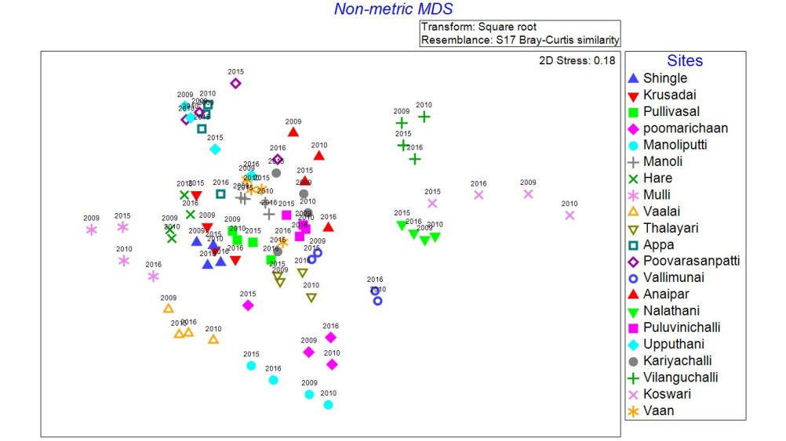

nmMDS ordination indicates temporal assemblage pattern of juvenile coral abundance in two bleaching events in GoM

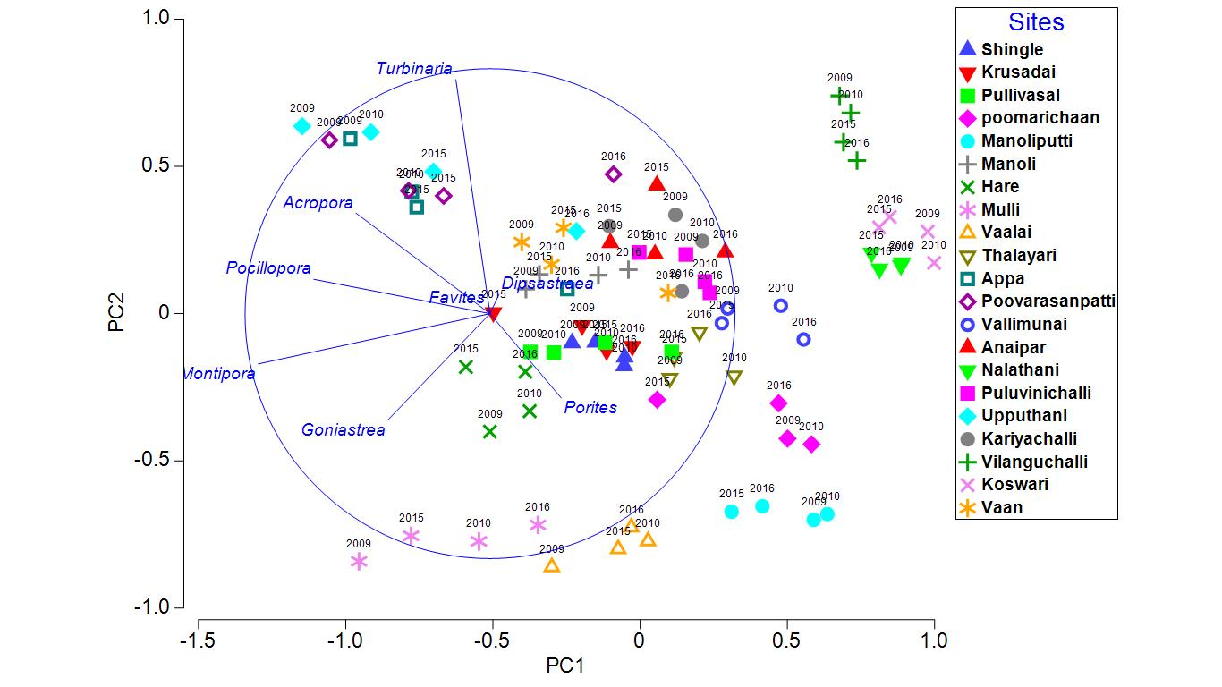

Fig. . Principal components analysis (PCA) of relative abundance of eight genera of juvenile
corals across21 sites in two bleaching events in GoM

Juvenile coral abundance Vs years
PERMANOVA table of results
Unique
Source df SS MS Pseudo-F P(perm) perms
Is 20 68437 3421.8 78.269 0.001 994
Res 294 12853 43.719
Total 314 81290

Principal components analysis between benthic variables and juvenile coral abundance
Data
Eigenvectors
(Coefficients in the linear combinations of variables making up PC's)
Variable PC1 PC2 PC3 PC4 PC5
LCC 0.843 -0.034 0.232 -0.196 -0.172
Soft coral 0.019 0.014 -0.014 0.122 0.904
Algae -0.321 0.767 0.244 -0.243 -0.153
CCA -0.036 0.007 -0.086 0.857 -0.301
Others -0.084 -0.125 -0.824 -0.332 -0.148
Abiotic -0.421 -0.628 0.448 -0.208 -0.131

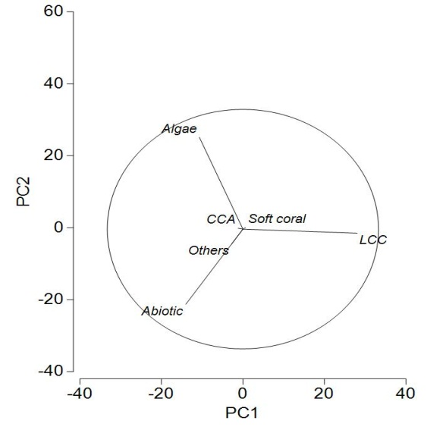

Fig. . Principal components analysis (PCA) of relative cover benthic variables
across21 sites in in GoM
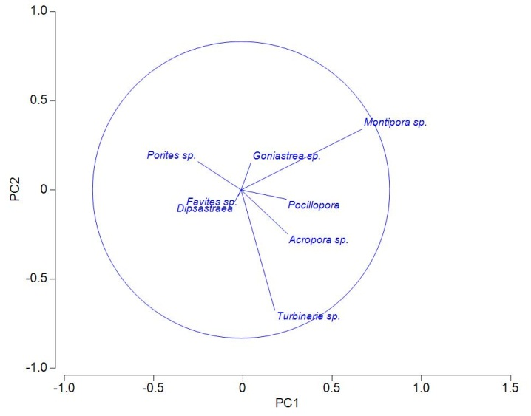

Fig. . Principal components analysis (PCA) of relative abundance of eight genera of juvenile
corals across21 sites in GoM
Data
Eigenvectors
(Coefficients in the linear combinations of variables making up PC's)
Variable PC1 PC2 PC3 PC4 PC5
Acropora sp. 0.313 -0.297 0.139 -0.626 0.628
Montipora sp. 0.816 0.411 0.199 0.183 -0.080
Pocillopora 0.305 -0.062 -0.097 -0.270 -0.468
Porites sp. -0.290 0.191 0.841 -0.300 -0.262
Turbinaria sp. 0.227 -0.812 0.262 0.223 -0.303
Dipsastraea -0.045 -0.083 -0.309 -0.337 -0.361
Favites sp. -0.018 -0.040 -0.197 -0.265 -0.185
Goniastrea sp. 0.067 0.185 -0.148 -0.421 -0.236

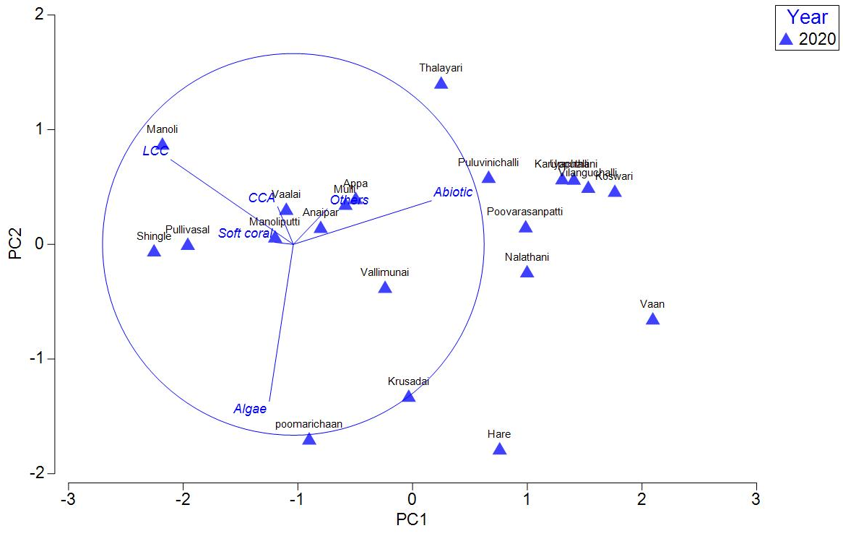

Fig. . Principal components analysis (PCA) of relative cover benthic variables
across21 sites during 2020
Data
Eigenvectors
(Coefficients in the linear combinations of variables making up PC's)
Variable PC1 PC2 PC3 PC4 PC5
LCC -0.642 0.444 0.005 0.285 0.132
Soft coral -0.096 0.011 0.910 -0.346 -0.182
Algae -0.126 -0.823 -0.077 -0.024 -0.033
CCA -0.082 0.197 -0.354 -0.887 0.071
Others 0.178 0.187 -0.166 0.072 -0.917
Abiotic 0.724 0.229 0.113 0.084 0.321

